

|  |
| --- |
| **Supply Chain** |

Jiarui XIE

Semester: 2018/2019

Superviser: Nicolas BERGERAS

Catalog

I. Introduction 1

II. Rabbit population growth 1

A. Flow-Process Diagram 1

B. Description of the Parameters 1

C. Performances 2

D. Simulate over Year 2

E. Simulate on Different Parameters 2

F. Confidence Interval at 95% 2

III. CONCLUSION 2

# First time

Engineer to Order: SoftwareDesign

Make to Order: Good Restaurant

Assemble to Order: DELL

Make to Stock: Suitcase，大部分商品都是这种属性，因为它们要给它一个很高的服务水品。

# Rabbit population growth

## Flow-Process Diagram

We first create two couple rabbits with the initial parameter, then scan the whole unmatured vector to judge are there any unmatured rabbit turn to mature. Then check if the matured vector turns into empty if yes then check does the loop finish if not we will wait the unmatured rabbits turn to mature, if yes we will stop. If the either of the matured vectors doesn’t empty, we will give birth to pups, then grow the pups as well as matured rabbits. Then judge whether they survived then move them into the corresponding vector. Finally, we will display the number of each vector. Like Figure1.1.

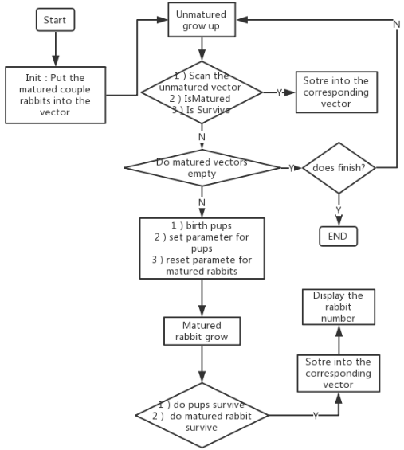

Figure1.1 Flow-process Diagram of this lab code

## Description of the Parameters

Female give 4 to 8 litters per year, but there is more chance to have 5,6 or 7 litters. We will use the Gaussian Distribution with the mean equal to 6 and the deviate equal 1. Like Figure1.2

Each litter will have 3 to 6 baby rabbits. We will use the Gaussian Distribution with the mean equal to 4 and the deviate equal 1. The possibility for gender is 50%. Like Figure1.3

Sexual maturity is reached between 5 to 8 months. We will use the Gaussian Distribution with the mean equal 7 and the deviate equal 1. Like Figure1.4

There will be a birth rate for the baby rabbit, for example, they face 80% possibility to death. In addition, for the matured rabbits they will face 50% risk to death at the same time when they reach 11 years old, they will also face 20% risk to death and this possibility will increase by 20% each year.

Figure1.2 histogram of the number of litters per female.

Figure1.3 histogram of the number of pups of a female per litter.

Figure1.4 histogram of the time needed to mature of a pup

## Performances

We tested the performance of our simulator based on the years with initialization is two couples on my local computer. The results for 5、6、7、8 and 9-year like Figure1.5. Obversely, the more initialization couples the more time it needs.

Figure1.5 time needed to simulate on different years

## Simulate over Year

We first simulated the reproduction of the population over different lengths of time. The graph in Figure1.6 shows the results obtained for 5、6、7、8 and 9-year simulations.

It appears on these graphs that whatever the simulate time the population obtained follows an exponential growth. This result is perfectly logical: the more adults there are, the more we get rabbits.

Figure1.6 Evolution of the size of the population

## Simulate on Different Parameters

We get the number of rabbits on different parameters, they are initialization number is two couples with the ratio of matured survived is 50% with the ratio of unmatured survived is 20%（2-20-50）、initialization number is two couples with the ratio of matured survived is 80% with the ratio of unmatured survived is 90%（2-80-90）、initialization number is four couples with the ratio of matured survived is 50% with the ratio of unmatured survived is 20%（4-20-50）、initialization number is two couple with the ratio of matured survived is 80% with the ratio of unmatured survived is 90%（4-80-90）.

Figure1.7 simulation based on different parameter

## Confidence Interval at 95%

We used the formulation in Lab3 to calculate the confidence interval at 95%. We used *init_genrand((unsigned long)time(NULL));* to get independent random streams and repeat ten times. The initialization number is two couples with the ratio of matured survived is 50% with the ratio of unmatured survived is 20%, simulated for five years.

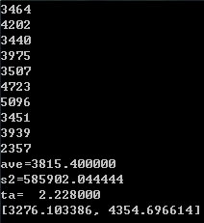

Figure1.8 confidence interval at 95%

# CONCLUSION

We have been able to establish a correct general model which seems to correspond to the results of our comrades. However, to be faithful to a real case, it lacks the consideration of many environmental parameters (terrain, nature, quantity of food, predators, diseases, and competitors...) and some intrinsic parameters, which can vary according to the species. Thus, our model can provide results far removed from actual observed results.